PYTHON UNIT 1
- Python introduction:-
python is a widely used general-purpose, high level programming language. It was created by Guido van Rossum in 1991 and further developed by the Python Software Foundation. It was designed with an emphasis on code readability, and its syntax allows programmers to express their concepts in fewer lines of code. Python is a programming language that lets you work quickly and integrate systems more efficiently.

Beginning with Python Programming:

1) Finding an Interpreter:
Before we start Python programming, we need to have an interpreter to interpret and run our programs. There are certain online interpreters like
Windows:
There are many interpreters available freely to run Python scripts like IDLE (Integrated Development Environment), that comes bundled with the Python software downloaded from
http://python.org/
- Reason for increasing popularity
- Emphasis on code readability, shorter codes, ease of writing
- Programmers can express logical concepts in fewer lines of code in comparison to languages such as C++ or Java.
- Python supports multiple programming paradigms, like object-oriented, imperative and functional programming or procedural.
- There exists inbuilt functions for almost all of the frequently used concepts.
- Philosophy is “Simplicity is the best”.
- LANGUAGE FEATURES
- Interpreted
  - There are no separate compilation and execution steps like C and C++.
  - Directly run the program from the source code.
  - Internally, Python converts the source code into an intermediate form called bytecodes which is then translated into native language of specific computer to run it.
  - No need to worry about linking and loading with libraries, etc.
- Platform Independent
  - Python programs can be developed and executed on multiple operating system platforms.
  - Python can be used on Linux, Windows, Macintosh, Solaris and many more.
- Free and Open Source; Redistributable
- High-level Language
  - In Python, no need to take care about low-level details such as managing the memory used by the program.
- Simple
  - Closer to English language;Easy to Learn
  - More emphasis on the solution to the problem rather than the syntax
- Embeddable
  - Python can be used within C/C++ program to give scripting capabilities for the program’s users.
- Robust:
  - Exceptional handling features
  - Memory management techniques in built
- Rich Library Support
  - The Python Standard Library is very vast.
  - Known as the “batteries included” philosophy of Python ;It can help do various things involving regular expressions, documentation generation, unit testing, threading, databases, web browsers, CGI, email, XML, HTML, WAV files, cryptography, GUI and many more.
  - Besides the standard library, there are various other high-quality libraries such as the Python Imaging Library which is an amazingly simple image manipulation library.

What are Interpreters?
Interpreters are the computer program that will convert the source code or an high level language into intermediate code (machine level language). It is also called translator in programming terminology. Interpreters executes each line of statements slowly. This process is called Interpretation. For example Python is an interpreted language, PHP, Ruby, and JavaScript.

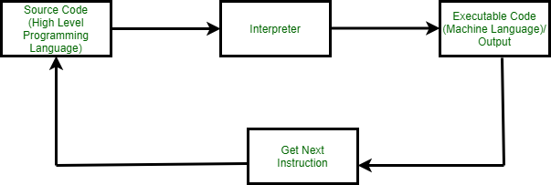

Advantages of using Interpreter
- It is flexible and error localization is easier.
- It is smaller in size.
- It executes line by line execution.
Disadvantages of using Interpreters
- It takes lot of time to translate.
- It is slower.
- It uses lot of storage.
Applications of Interpreters
- They are used to execute common languages by using editor or an compiler.
- Easy implementation of self modifying code.
- Virtualization.
- Sandboxing.
- Emulators.

How to Install Python in Windows?

Step 1: Select Version to Install Python
Visit the official page for Python https://www.python.org/downloads/ on the Windows operating system. Locate a reliable version of Python 3, preferably version 3.10.11, which was used in testing this tutorial. Choose the correct link for your device from the options provided: either Windows installer (64-bit) or Windows installer (32-bit) and proceed to download the executable file.
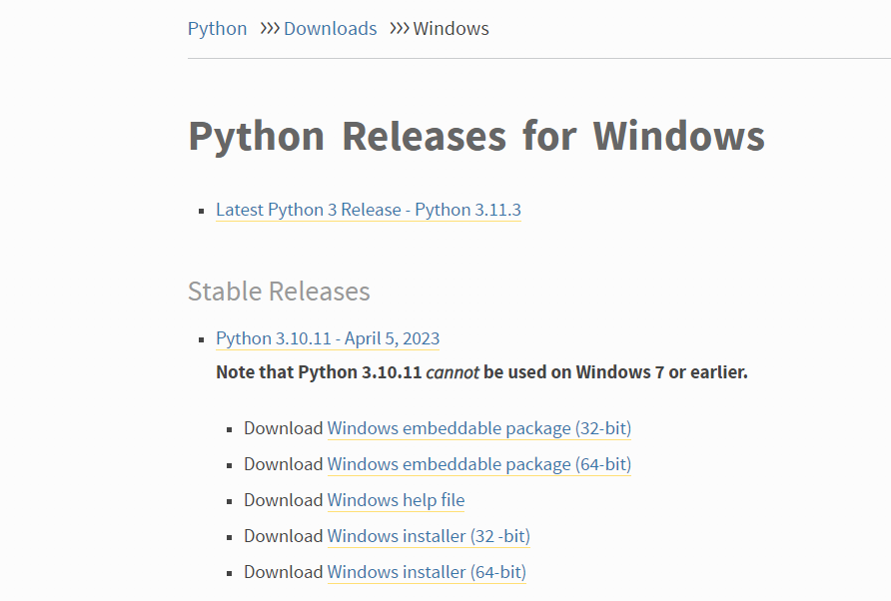
Step 2: Downloading the Python Installer
Once you have downloaded the installer, open the .exe file, such as python-3.10.11-amd64.exe, by double-clicking it to launch the Python installer. Choose the option to Install the launcher for all users by checking the corresponding checkbox, so that all users of the computer can access the Python launcher application.Enable users to run Python from the command line by checking the Add python.exe to PATH checkbox.
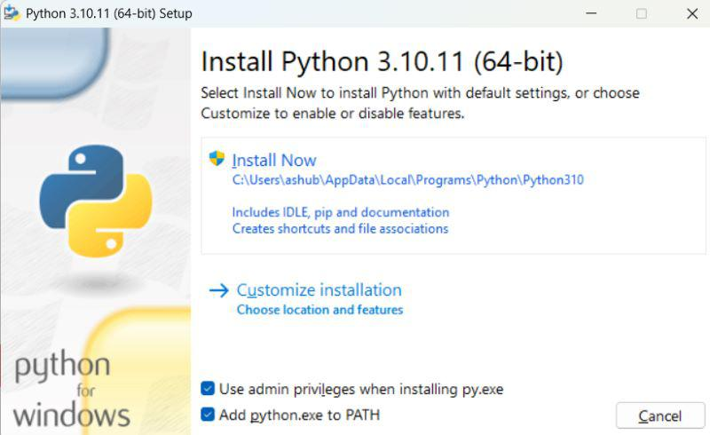
After Clicking the Install Now Button the setup will start installing Python on your Windows system. You will see a window like this.
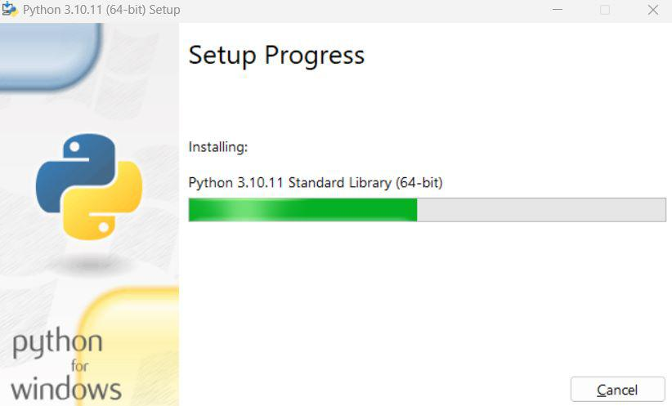
Step 3: Running the Executable Installer
After completing the setup. Python will be installed on your Windows system. You will see a successful message.
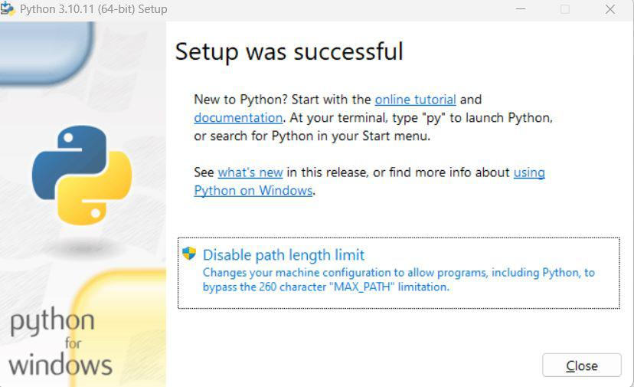
Step 4: Verify the Python Installation in Windows
Close the window after successful installation of Python. You can check if the installation of Python was successful by using either the command line or the Integrated Development Environment (IDLE), which you may have installed. To access the command line, click on the Start menu and type “cmd” in the search bar. Then click on Command Prompt.
python --version
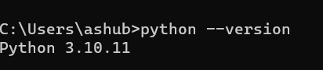
You can also check the version of Python by opening the IDLE application. Go to Start and enter IDLE in the search bar and then click the IDLE app, for example, IDLE (Python 3.10.11 64-bit). If you can see the Python IDLE window then you are successfully able to download and installed Python on Windows.
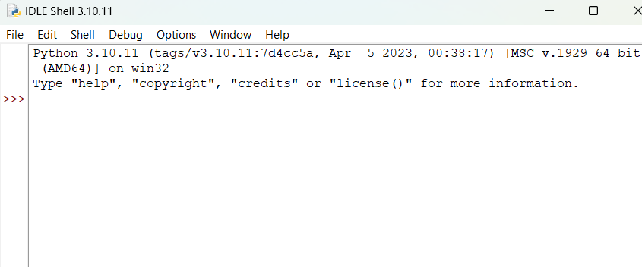

Writing your first program:-
  - print('Hello World!') output: Hello World!
  - print(20+35) output: 55
  - print(25) output: 25
  - print("my name is xyz.","my age is 35.") output: my name is xyz. my age is 35.

